ESP Lab1: Short Report

Signal Modulation by Decimation and Interpolation
Group / Team | Team member 1: | Pham, Tuong Minh
ESPL01 / 5 (please change) | Team member 2: | Ul Haq, Waleed
ESPL01 / 5 (please change) | Team member 3: | First, Last name (please change)
Table 1: Different configurations to be used by different lab groups
Lab group as chosen in myHAW | Down- / Upsampling factor | Chirp, from … to [kHz], length [s] |  | Bat sound $f_{bat}$ | Sampling frequency ADC, DAC $f_{s}$ [kHz] | Polyphases $x_{λ}$ output at DAC CH0 / CH1
ESPL/01 | M=L=3 | 18 … 21 kHz | 2.5 s | 18 kHz | 50 kHz, 50 kHz | $$λ=0 / λ=2$$
ESPL/02 | M=L=4 | 14 … 17 kHz | 3.0 s | 15 kHz | 50 kHz, 50 kHz | $$λ=0 / λ=3$$
ESPL/03 | M=L=5 | 21 … 24 kHz | 2.0 s | 17 kHz | 50 kHz, 50 kHz | $$λ=0 / λ=4$$
ESPL/04 | M=L=5 | 18 … 21 kHz | 3.0 s | 16 kHz | 50 kHz, 50 kHz | $$λ=0 / λ=3$$

Lab task

Echo program
Take a screenshot of the amplitude response and attach it to the lab report. In the report, describe the shape of the frequency response and explain how this affects signal transmission in the DSP system.

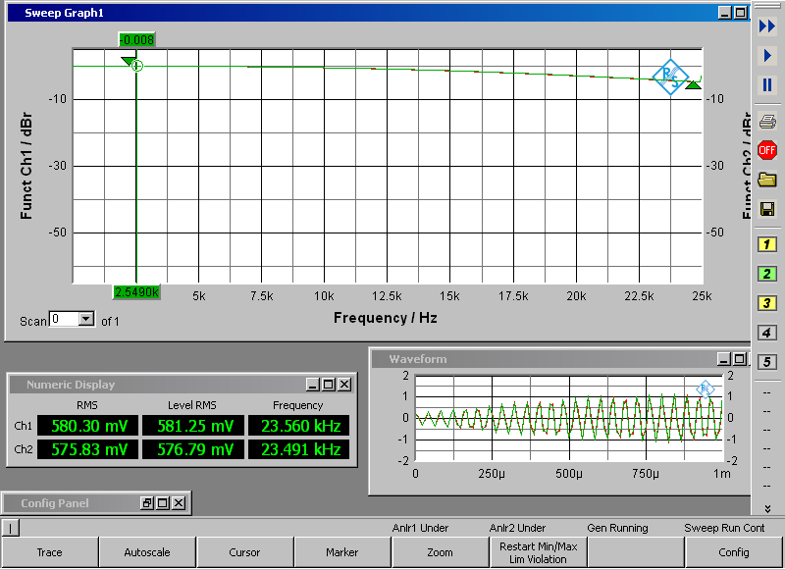

A low pass behavior can be seen at the amplitude response. Our Signals are in the range from 0 Hz to 21 kHz. This has a little effect that our signals are little bit attenuated in the higher frequency range.

Implementation of multirate system
After successful testing, insert the final C code of adcInt() and dacInt() into the lab report. Apply a sine wave of frequency $f_{bat}$ as specified in Table 1 for your group to both inputs of the system and measure the amplitude spectrum via FFT at the output. Take a screenshot for the report. Increase the frequency by 5$kHz$ and compare the amplitude spectrum to the previous. Explain your observations.

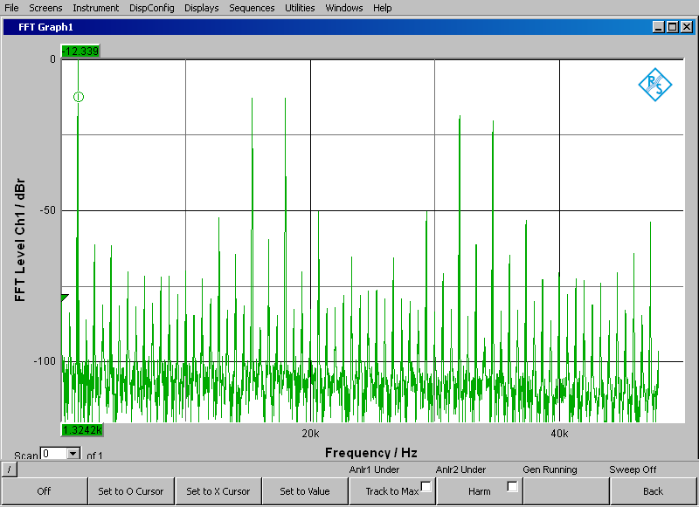
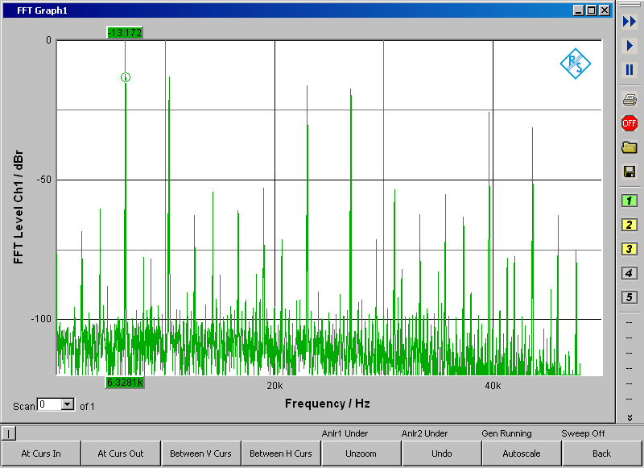
We can see at fbat = 18kHz our top plot and the expected peak at 1.3kHz and 15.33kHz as described in the preparation. And if we increase our bat frequency to 23kHz then the other peaks will be shifted 5kHz increased with the new sample frequency as before. (1.3kHz is now at 6.3kHz)

Insert the interpolation filter
Compare amplitude spectra and time-domain signals of both DAC channels 0 and 1 again for the bat frequency $f_{bat}$ as given in the Table 1. Add relevant screenshots to your report and explain the results.

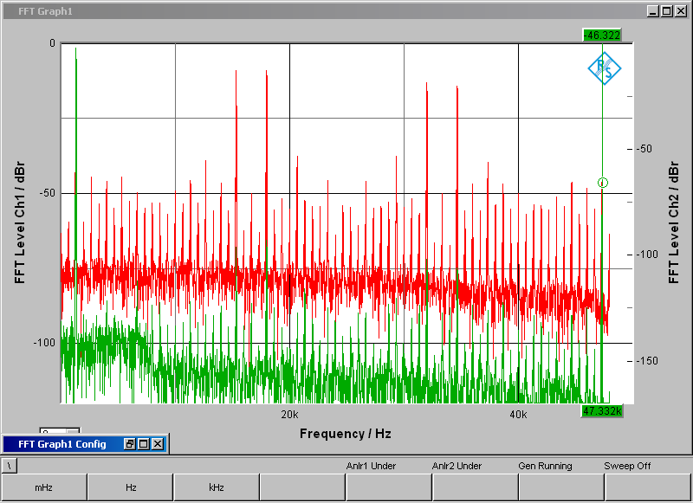

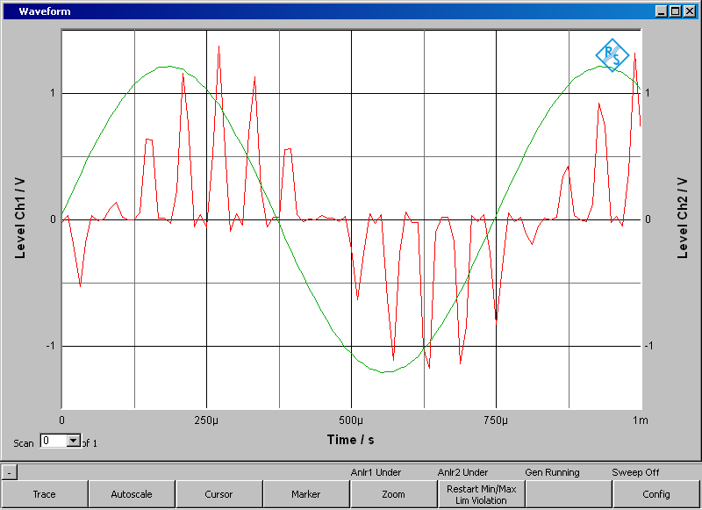
The red signal is the upsampled signal without the interpolation filter. It can be seen in the frequency plot that the low-pass filter is filtering the image spectra (the unwanted peaks at 15 and 18kHz) with 60dB attenuation and that signal is successfully interpolated.

Optional task: let the bats fly
A wave file containing bat sounds has been stored on the internship computer. These are not the original sounds, which are in the 40-50 kHz range, but were shifted to the upper human hearing range. Input the signal to your system and compare the animal sounds at input and output of the multirate system and with and without interpolation filters by listening and using the audio analyzer.
Congratulations! You made it. Please submit with 15 min. after end of the session.

